Empathy Map Canvas

***Feels uncomfortable***

***Enrich the lives of elderly people with the modern days***

Starts a food diary

I couldn't find the food that I want

Will try to maintain the diet properly

***Looking for food that matches interest***

***Menu with healthy receipes***

***Does it working***

***People looking for alternatives and more practical ways overcoming thier disabilitty***

Gain insight and understanding on solving customer problems.

1

Build empathy and keep your focus on the user by putting yourself in their shoes.

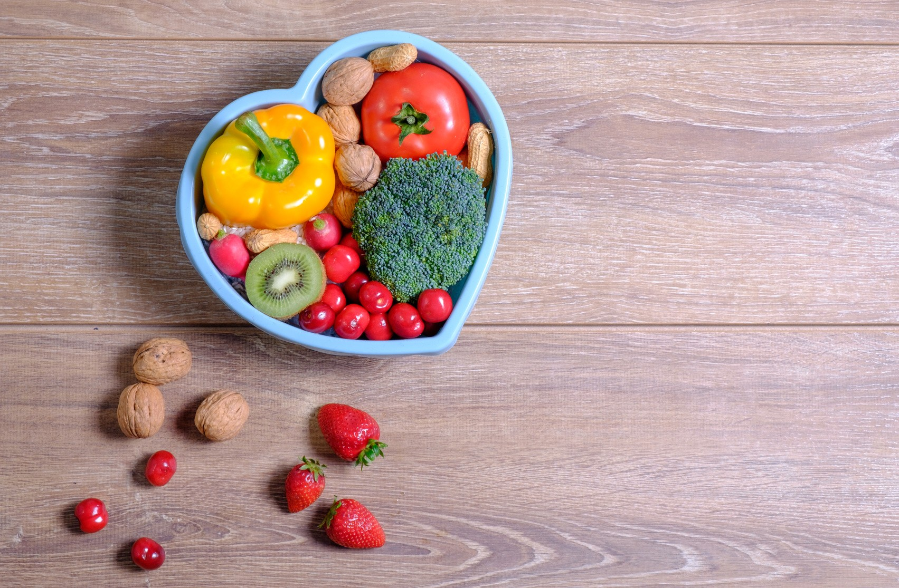

What should I eat today?

Doesn't want junk food

I need to plan my diet properly

***I want to burn calories but i don't know how to do thet***

***Share your feedback***

***Maintaining the calories level***

***Do you following the diet properly?***

***Difficult to find food interest***

***Hard to follow the diet***

***Feels healthy***

***Measures of success***